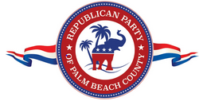
Dear Supporter,
The Republican Party of Palm Beach County is proud to announce the Annual Lincoln Day Dinner Gala at Mar-a-Lago in Palm Beach on Friday, March 20 beginning at 5:00 p.m., to celebrate America’s 250th Birthday! Tickets are still available for purchase.
[Button to purchase tickets]
In addition, the Republican Party is offering a valuable opportunity to advertise your business, products, or services to more than 700 attendees, including honorees, award winners, elected officials, candidates, and members.
Reasonably priced ads range from $175 to $2,000. Please note that all photos or logos must be submitted as high-resolution (300 dpi) files in JPEG or PDF format.
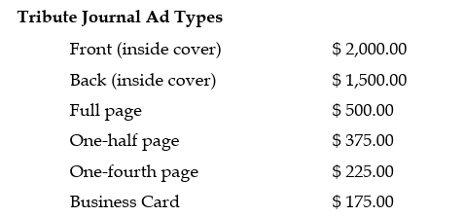
If you are interested in taking advantage and supporting the party, or know of someone who may be interested, please contact Casidy at casidy73@gmail.com or call 707-481-7021.
Click below for access the form (scroll down) or call for more information.
[Button to ad journal form]
We look forward to your participation.
Sincerely,
Republican Party of Palm Beach County

